Low-Level Design (LLD) — Complaint Closure Flow
Attribute | Value
Document focus | Complaint Closure only (Yes → Resolved / No → Reassign + Re-Open)
Module | Complaint Entry (complaint-entry)
Host UI | new_complaint.php → Closure modal
Save endpoint | closure_complaint.php (POST)
Stack (target) | Core PHP + MySQL (PDO)
Stack (current repo) | Core PHP + PostgreSQL via PDO
Document version | 1.0

Out of scope: Complaint create, initial assign, Assigned Complaint List UI, Service Update save (covered elsewhere). Service Update is a prerequisite only.
â”€â”€â”€â”€â”€â”€â”€â”€â”€â”€â”€â”€â”€â”€â”€â”€â”€â”€â”€â”€â”€â”€â”€â”€â”€â”€â”€â”€â”€â”€â”€â”€

1. Module Overview

1.1 Purpose
After a Service Update moves a complaint to Pending With HO, a CCS Admin with complaint-closure permission marks Call Closure:
â€¢ Yes → record closure remarks + customer feedback (1–10) → status Resolved
â€¢ No → reassign to an engineer (requires reassign-complaint) → status Re-Open (returns to Assigned List after new Service Update cycle)

1.2 Scope
In scope | Out of scope
Closure modal on Complaint Entry history | Creating / editing complaint master fields
closure_complaint.php POST save | Service Update form itself
Closure = Yes / No business rules | Soft-delete
Reassignment on Closure = No | Installed Base / Service Log CRUD
Closure / reassignment emails
CCS Pending HO nudge cron (related)

1.3 High-level architecture
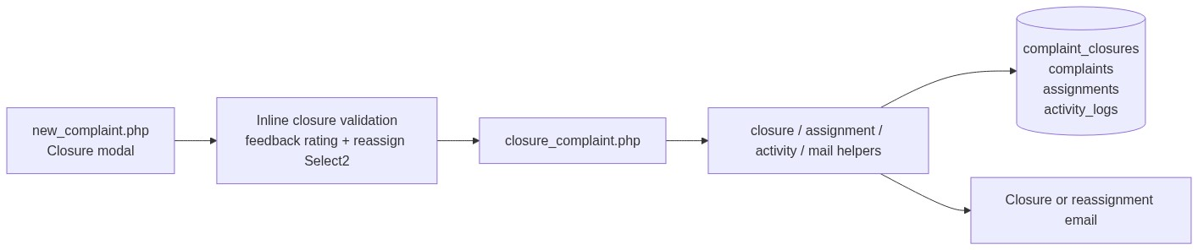
Figure 1 â€” High-level architecture
â”€â”€â”€â”€â”€â”€â”€â”€â”€â”€â”€â”€â”€â”€â”€â”€â”€â”€â”€â”€â”€â”€â”€â”€â”€â”€â”€â”€â”€â”€â”€â”€

2. Functional Requirements
ID | Requirement | Priority
FR-01 | Closure only for CCS Admin + complaint-closure | Must
FR-02 | Closure button only when Pending With HO + service update exists + not already closed Yes | Must
FR-03 | Call Closure Yes requires remarks + feedback 1–10 | Must
FR-04 | Call Closure Yes → status Resolved + closure email to latest assignee | Must
FR-05 | Call Closure No requires Assign To + reassign-complaint | Must
FR-06 | Call Closure No → new assignment + status Re-Open + reassignment email | Must
FR-07 | After Closure No + new Service Update + back to Pending With HO, Closure can be used again | Must
FR-08 | After Closure Yes, Closure button never shown again | Must
FR-09 | Activity logs for Closure and Reassignment | Must
FR-10 | Optional CCS Pending HO nudge reminders (cron) | Should

â”€â”€â”€â”€â”€â”€â”€â”€â”€â”€â”€â”€â”€â”€â”€â”€â”€â”€â”€â”€â”€â”€â”€â”€â”€â”€â”€â”€â”€â”€â”€â”€

3. User Roles & Permissions

3.1 RBAC module slug
complaint-entry

3.2 Permission matrix (closure)
Permission / gate | Capability
Role CCS Admin (CCS_ADMIN_ROLE = 7) | Hard role gate
complaint-closure | Allowed to open/save Closure
reassign-complaint | Closure = No path (radio + Assign To)

Combined: complaint_user_can_closure() = CCS Admin AND complaint-closure.
Denial: Access denied. Complaint closure is available to CCS Admin users with the required permission only.

3.3 Page / API mapping
Resource | Gate
Closure modal on new_complaint.php | complaint_user_can_closure()
closure_complaint.php | complaint_entry_require_closure_permission()
Closure = No branch | Extra complaint_entry_require_permission(..., 'reassign-complaint')
api/complaint_assign_options.php | assign or reassign or closure
api/complaints_datatable.php | Renders Closure button via can_close

3.4 List scope
Closure actions appear on Complaint Entry history (api/complaints_datatable.php) under entry list scope. Actor must still pass CCS + closure permission for the button/modal.
â”€â”€â”€â”€â”€â”€â”€â”€â”€â”€â”€â”€â”€â”€â”€â”€â”€â”€â”€â”€â”€â”€â”€â”€â”€â”€â”€â”€â”€â”€â”€â”€

4. Business Rules
ID | Rule
BR-01 | Status must be Pending With HO (3).
BR-02 | ≥1 complaint_service_updates row required.
BR-03 | Closure button hidden if latest closure is Yes.
BR-04 | After Closure No, button can return only when status is again Pending With HO and a service update exists after that No (re-close eligibility).
BR-05 | Yes: remarks required; feedback integer 1–10; closure_datetime set; status → Resolved (5).
BR-06 | No: Assign To required; optional remarks ≤ 500; new complaint_assignments with is_service_updated default 0; status → Re-Open (4).
BR-07 | No path validates assignee (dealer self-only / ELGi Engineer rules).
BR-08 | Activity order on No: Reassignment then Closure.
BR-09 | Yes path activity: Closure only.
BR-10 | Does not modify complaint_service_updates rows.

â”€â”€â”€â”€â”€â”€â”€â”€â”€â”€â”€â”€â”€â”€â”€â”€â”€â”€â”€â”€â”€â”€â”€â”€â”€â”€â”€â”€â”€â”€â”€â”€

5. Database Design

5.1 ER diagram
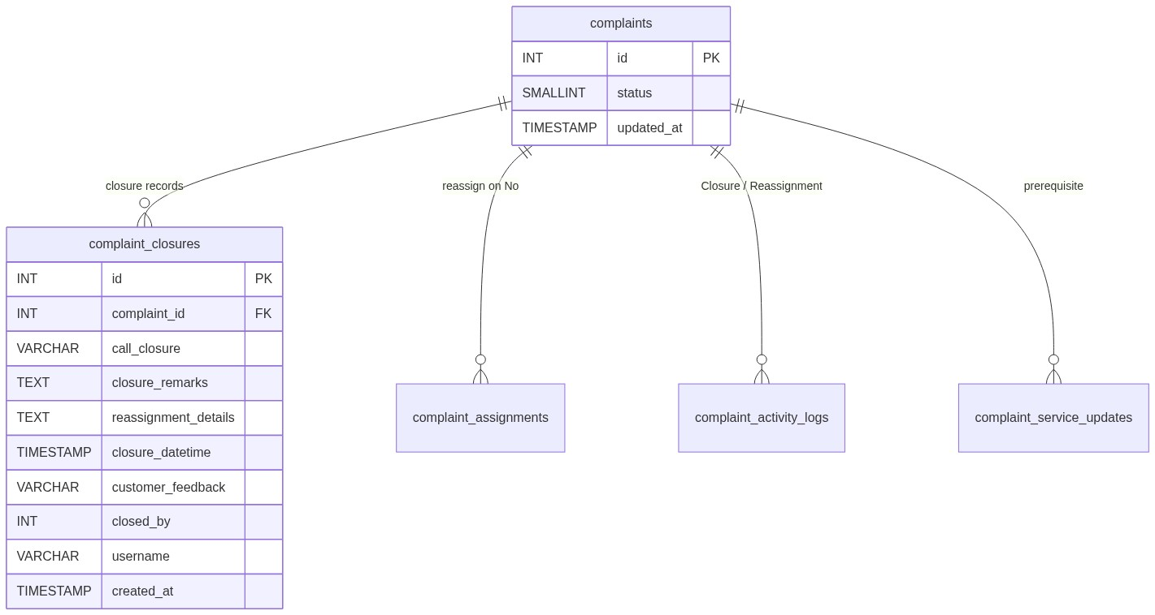
Figure 2 â€” Entity relationship diagram

5.2 Table: complaint_closures
Column | MySQL type | Yes | No
id | INT UNSIGNED AUTO_INCREMENT | auto | auto
complaint_id | INT UNSIGNED | set | set
call_closure | VARCHAR(10) | Yes | No
closure_remarks | TEXT | required | NULL
reassignment_details | TEXT | NULL | reassign remarks (nullable)
closure_datetime | TIMESTAMP | set | NULL
customer_feedback | VARCHAR(100) | "1"–"10" | NULL
closed_by | INT UNSIGNED | actor | actor
username | VARCHAR(100) | actor | actor
created_at | TIMESTAMP | default | default

5.3 Related tables
Table | Change on closure
complaints | status = 5 or 4; updated_at now
complaint_assignments | New row on No only
complaint_activity_logs | Closure / Reassignment
complaint_service_updates | Read-only prerequisite

5.4 Reference / lookup sources
Source | Usage
api/complaint_assign_options.php | Reassign Select2
Status constants | Pending With HO / Re-Open / Resolved
Feedback 1–10 | complaint_closure_helpers.php

â”€â”€â”€â”€â”€â”€â”€â”€â”€â”€â”€â”€â”€â”€â”€â”€â”€â”€â”€â”€â”€â”€â”€â”€â”€â”€â”€â”€â”€â”€â”€â”€

6. API / Backend Design

6.1 Page endpoints
Endpoint | Method | Auth | Description
new_complaint.php | GET | view + closure UI if allowed | Hosts #closureModal
closure_complaint.php | POST save_closure | CCS + complaint-closure | Persist Yes/No
Non-POST to closure | — | — | Redirect new_complaint.php

POST fields
Field | Yes | No
complaint_id | required | required
call_closure | Yes | No
closure_remarks | required | ignored
customer_feedback | required 1–10 | ignored
reassign_complaint | — | required
reassign_remarks | — | optional ≤ 500

6.2 JSON APIs
API | Role
api/complaints_datatable.php | can_close flags + Closure button
api/complaint_assign_options.php | Reassign assignees

6.3 Supporting lookup APIs
Assignee options for Closure = No Select2 (same assign-options API).

6.4 Core PHP responsibilities
File | Role
closure_complaint.php | Orchestration + transaction
complaint_closure_helpers.php | Feedback validate/display
complaint_datatable_helpers.php | Closure permission + can_close
complaint_activity_helpers.php | Activity insert
complaint_assignment_helpers.php | Reassign validate/resolve
complaint_assignment_mail_helpers.php | Closure / reassignment emails
admin_access_helpers.php | CCS Admin check

â”€â”€â”€â”€â”€â”€â”€â”€â”€â”€â”€â”€â”€â”€â”€â”€â”€â”€â”€â”€â”€â”€â”€â”€â”€â”€â”€â”€â”€â”€â”€â”€

7. Validation Rules

7.1 Server-side
Condition | Message
Invalid Yes/No | Please select call closure Yes or No.
Yes, empty remarks | Closure remarks are required when call closure is Yes.
Yes, empty/invalid feedback | Customer feedback is required when call closure is Yes. / Please select a customer feedback rating between 1 and 10.
No, empty assignee | Reassign Assign To is required when call closure is No.
No, remarks > 500 | Remarks cannot exceed 500 characters.
Wrong status | Closure is only allowed for complaints pending with HO.
No service update | Service update is required before complaint closure.
Not found | Complaint not found.
No user | Unable to resolve logged-in user.
Persist fail | Failed to save complaint closure.
No CCS/closure | Access denied. Complaint closure is available to CCS Admin users with the required permission only.
No reassign perm | Access denied. You do not have permission for this action.

7.2 Client-side (inline on new_complaint.php)
Field | Message
call_closure | Please select Call Closure Yes or No
closure_remarks | Closure remarks are required
customer_feedback | Please select a customer feedback rating between 1 and 10
reassign_complaint | Reassign to is required
reassign_remarks | Remarks cannot exceed 500 characters

Note: js/closure_validation.js mirrors this but is not loaded by the page.
â”€â”€â”€â”€â”€â”€â”€â”€â”€â”€â”€â”€â”€â”€â”€â”€â”€â”€â”€â”€â”€â”€â”€â”€â”€â”€â”€â”€â”€â”€â”€â”€

8. UI Screen Specifications

8.1 Listing
On Complaint Entry history, Complaint Closure action (.closure-btn) when can_close && permissions.closure.

8.2 Form panel
N/A — closure is modal-only.

8.3 Details
complaint_details.php shows closure history (read-only), including feedback stars for 1–10.

8.4 Modals
#closureModal — title Complaint Closure; subtitle Mark call closure and resolve or reassign the complaint.
Section | Fields
Closure Decision | Radios Yes / No (No disabled without reassign)
Closure Remarks (Yes) | Remarks textarea + 1–10 star feedback
Reassignment (No) | Assign To Select2 + optional remarks

Submit: Save Closure → closure_complaint.php.
â”€â”€â”€â”€â”€â”€â”€â”€â”€â”€â”€â”€â”€â”€â”€â”€â”€â”€â”€â”€â”€â”€â”€â”€â”€â”€â”€â”€â”€â”€â”€â”€

9. Database Flow

9.1 Create (persist closure)
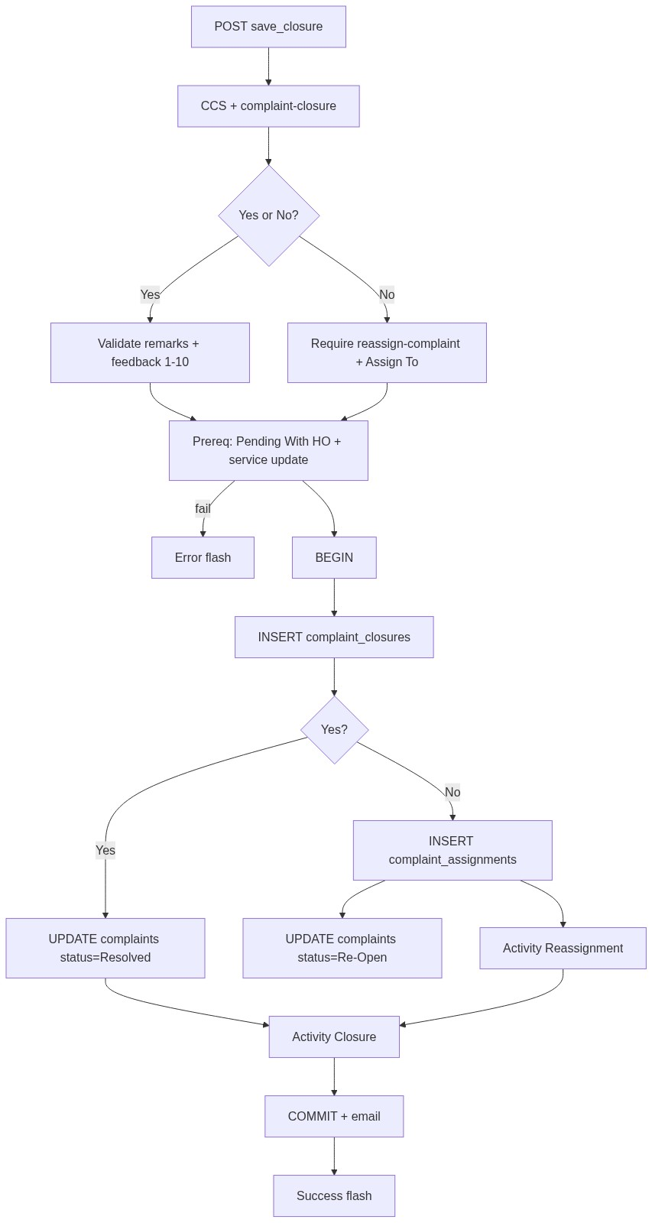
Figure 3 â€” Create database flow

9.2 Soft-delete
Not part of closure flow.

9.3 List query pattern (button eligibility)
status = Pending With HO (3)
AND has_service_update
AND latest_closure <> 'Yes'
AND (
latest_closure IS NULL
OR (latest_closure = 'No' AND has_service_after_closure_no)
)
AND user can_closure
â”€â”€â”€â”€â”€â”€â”€â”€â”€â”€â”€â”€â”€â”€â”€â”€â”€â”€â”€â”€â”€â”€â”€â”€â”€â”€â”€â”€â”€â”€â”€â”€

10. Sequence Diagram

10.1 Closure = Yes → Resolved
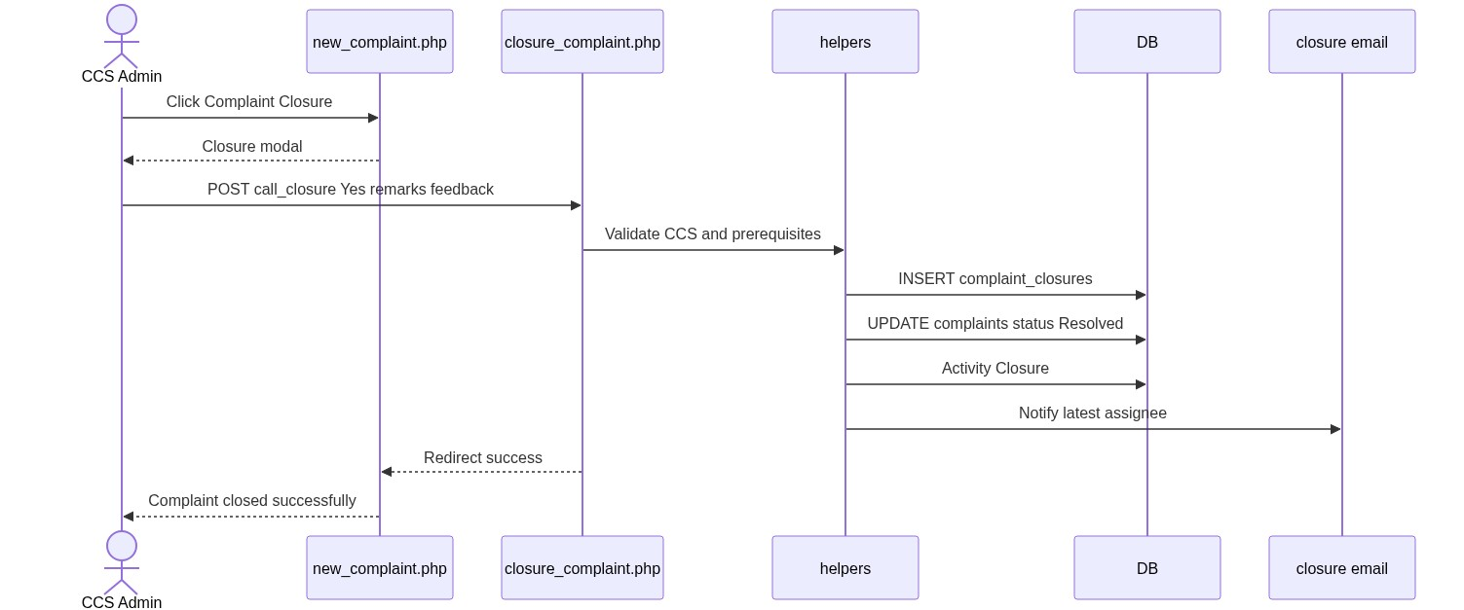
Figure 4 â€” Sequence: Create / update on Spare Parts page

10.2 Closure = No → Reassign + Re-Open
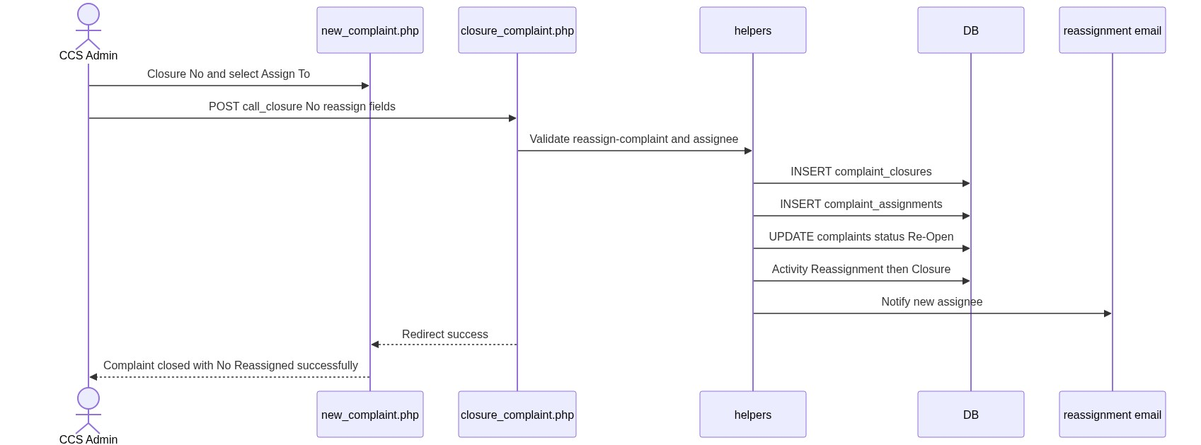
Figure 5 â€” Sequence: Add Spare Parts from IB / SL row
â”€â”€â”€â”€â”€â”€â”€â”€â”€â”€â”€â”€â”€â”€â”€â”€â”€â”€â”€â”€â”€â”€â”€â”€â”€â”€â”€â”€â”€â”€â”€â”€

11. Activity Diagram
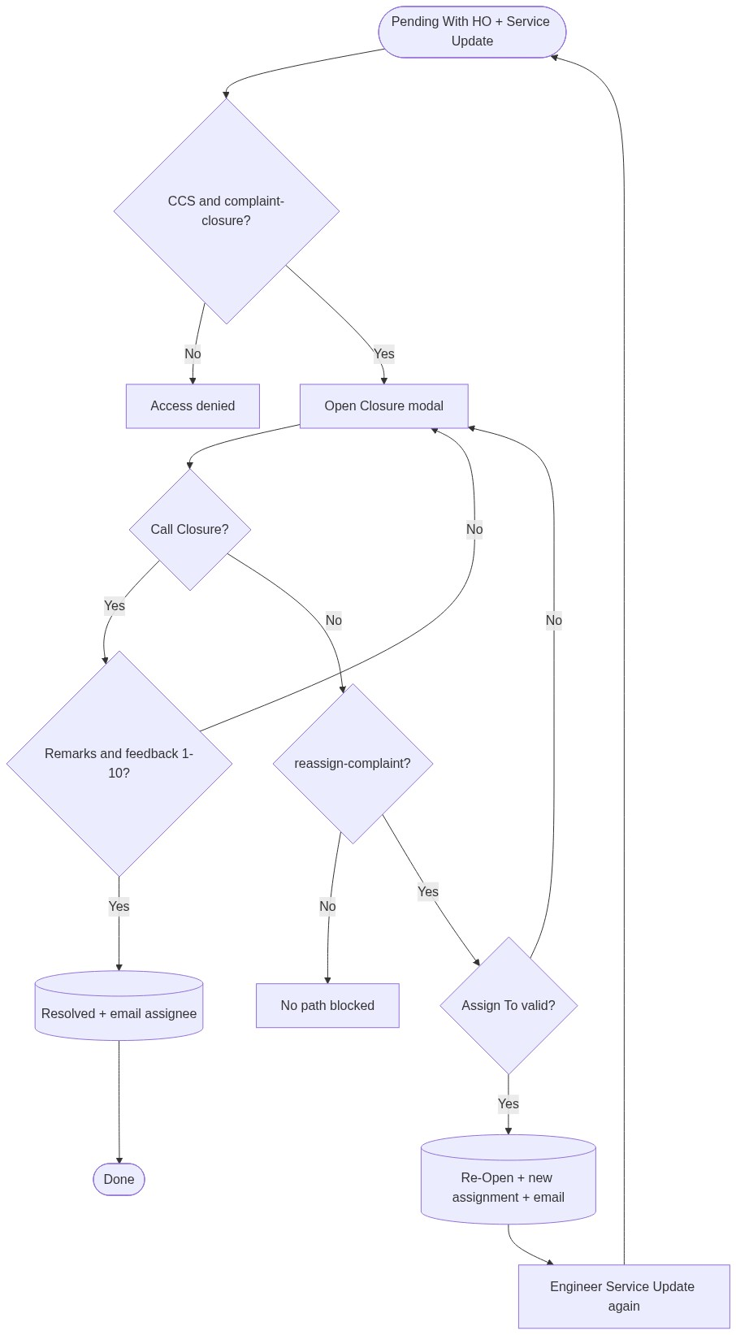
Figure 6 â€” Activity diagram
â”€â”€â”€â”€â”€â”€â”€â”€â”€â”€â”€â”€â”€â”€â”€â”€â”€â”€â”€â”€â”€â”€â”€â”€â”€â”€â”€â”€â”€â”€â”€â”€

12. Class / Module Diagram
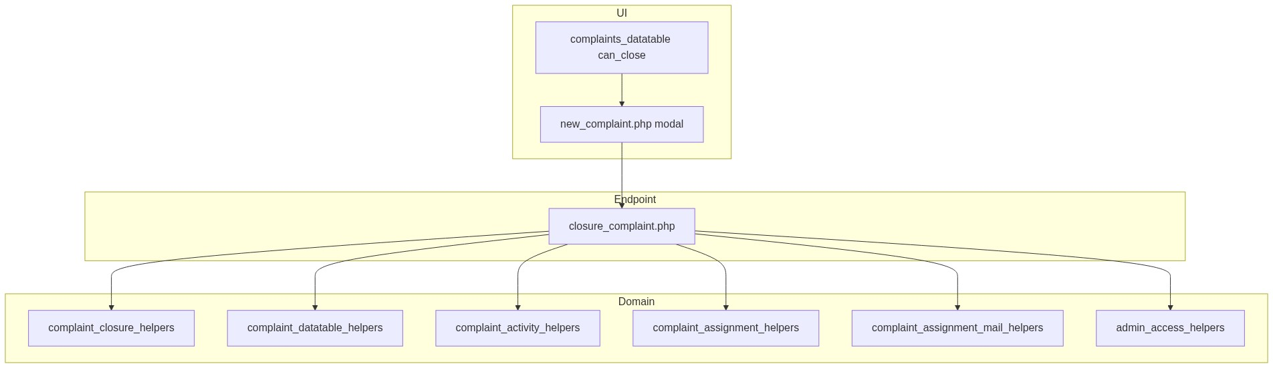
Figure 7 â€” Class / module diagram

12.1 Key functions
Function | Role
complaint_user_can_closure() | CCS + complaint-closure
complaint_entry_require_closure_permission() | Server enforce
dt_parse_closure_row_flags() / can_close | Button eligibility
complaint_closure_validate_customer_feedback() | 1–10
complaint_validate_assignee_for_complaint() | Reassign rules
complaint_log_activity() | Closure / Reassignment
complaint_closure_notify_email() | Yes path mail
complaint_assignment_notify_email(..., true) | No path reassignment mail

â”€â”€â”€â”€â”€â”€â”€â”€â”€â”€â”€â”€â”€â”€â”€â”€â”€â”€â”€â”€â”€â”€â”€â”€â”€â”€â”€â”€â”€â”€â”€â”€

13. Folder Structure
ComplaintManagement/
├── closure_complaint.php
├── new_complaint.php
├── complaint_details.php
├── api/
│ ├── complaints_datatable.php
│ └── complaint_assign_options.php
├── includes/
│ ├── complaint_closure_helpers.php
│ ├── complaint_datatable_helpers.php
│ ├── complaint_activity_helpers.php
│ ├── complaint_assignment_helpers.php
│ ├── complaint_assignment_mail_helpers.php
│ ├── complaint_status.php
│ └── admin_access_helpers.php
├── js/
│ ├── closure_customer_feedback_rating.js
│ └── assign_to_select2.js
├── cron/
│ ├── complaint_ccs_closure_nudge.php
│ └── complaint_ccs_closure_nudge_helpers.php
└── docs/
└── LLD_Complaint_Closure_Flow.md
â”€â”€â”€â”€â”€â”€â”€â”€â”€â”€â”€â”€â”€â”€â”€â”€â”€â”€â”€â”€â”€â”€â”€â”€â”€â”€â”€â”€â”€â”€â”€â”€

14. Error Handling
Layer | Pattern
POST | Session error_message / success_message → redirect new_complaint.php
Client | Inline validate.js before submit
Non-POST | Redirect list

14.1 Common messages
Message | When
Complaint closed successfully. | Yes success
Complaint closed with No. Reassigned successfully. | No success
Closure is only allowed for complaints pending with HO. | Wrong status
Service update is required before complaint closure. | Missing SU
Failed to save complaint closure. | Exception

â”€â”€â”€â”€â”€â”€â”€â”€â”€â”€â”€â”€â”€â”€â”€â”€â”€â”€â”€â”€â”€â”€â”€â”€â”€â”€â”€â”€â”€â”€â”€â”€

15. Security Considerations
Area | Control
AuthZ | CCS Admin role + complaint-closure; No path needs reassign-complaint
Status gate | Pending With HO only
Prerequisite | Service update must exist
SQL Injection | PDO binds
XSS | Escaped flashes / details
CSRF | Session POST; recommend CSRF tokens
Assignee integrity | Same dealer/engineer validation as assign

â”€â”€â”€â”€â”€â”€â”€â”€â”€â”€â”€â”€â”€â”€â”€â”€â”€â”€â”€â”€â”€â”€â”€â”€â”€â”€â”€â”€â”€â”€â”€â”€

16. Audit Logs

16.1 Built-in field-level audit
Store | Content
complaint_closures | closed_by, username, created_at, closure_datetime (Yes)
complaint_activity_logs | Closure / Reassignment + description
complaints | updated_at
complaint_assignments | assigned_by, username (No path)

Activity text (examples):
â€¢ Yes: Call closure marked Yes. Complaint resolved. + remarks + Customer feedback: {n}/10. + Status changed to Resolved.
â€¢ No reassignment: Complaint reassigned to {name} on {date} after closure No.
â€¢ No closure: Call closure marked No. Complaint reassigned to {name}. Status changed to Re-Open.
â”€â”€â”€â”€â”€â”€â”€â”€â”€â”€â”€â”€â”€â”€â”€â”€â”€â”€â”€â”€â”€â”€â”€â”€â”€â”€â”€â”€â”€â”€â”€â”€

17. Test Cases

17.1 Functional
ID | Scenario | Expected
TC-01 | Non-CCS tries closure | Denied
TC-02 | CCS without complaint-closure | Denied
TC-03 | Close In Progress (no Pending HO) | Rejected
TC-04 | Pending HO without service update | Rejected
TC-05 | Yes without remarks/feedback | Validation error
TC-06 | Yes valid | Resolved; email; success flash; button gone
TC-07 | No without reassign permission | Radio/section blocked / server deny
TC-08 | No without Assign To | Validation error
TC-09 | No valid | Re-Open; new assignment; emails; success flash
TC-10 | After No + new SU + Pending HO | Closure button returns
TC-11 | After Yes | Closure button never returns
TC-12 | Details shows closure history / feedback stars | Correct display

â”€â”€â”€â”€â”€â”€â”€â”€â”€â”€â”€â”€â”€â”€â”€â”€â”€â”€â”€â”€â”€â”€â”€â”€â”€â”€â”€â”€â”€â”€â”€â”€

18. Assumptions & Dependencies

18.1 Assumptions
1. Service Update has already set status to Pending With HO and written complaint_service_updates.
2. CCS Admin role id = 7 and complaint-closure / reassign-complaint are seeded.
3. Mail transport is configured for closure/reassignment notifications.
4. Document target stack Core PHP + MySQL; repo runs PostgreSQL.

18.2 Dependencies
Dependency | Purpose
Assigned List / Service Update | Prerequisite SU + Pending With HO
Complaint Entry history UI | Modal host + button
Assignment helpers / mail | Reassign + notify
Feedback rating JS | 1–10 UI
Optional cron nudge | Pending HO reminders

â”€â”€â”€â”€â”€â”€â”€â”€â”€â”€â”€â”€â”€â”€â”€â”€â”€â”€â”€â”€â”€â”€â”€â”€â”€â”€â”€â”€â”€â”€â”€â”€

Appendix A — Success messages
Event | Message
Closure Yes | Complaint closed successfully.
Closure No | Complaint closed with No. Reassigned successfully.

â”€â”€â”€â”€â”€â”€â”€â”€â”€â”€â”€â”€â”€â”€â”€â”€â”€â”€â”€â”€â”€â”€â”€â”€â”€â”€â”€â”€â”€â”€â”€â”€

Appendix B — Select2 control map
Control | Where | API
Reassign Assign To | Closure modal (No) | api/complaint_assign_options.php via assign_to_select2.js

â”€â”€â”€â”€â”€â”€â”€â”€â”€â”€â”€â”€â”€â”€â”€â”€â”€â”€â”€â”€â”€â”€â”€â”€â”€â”€â”€â”€â”€â”€â”€â”€

Appendix C — Status sequence
Service Update --> Pending With HO (3)
|
+------------+------------+
| Call Closure Yes | Call Closure No
v v
Resolved (5) Re-Open (4) + new assignment
|
+--> Service Update --> Pending With HO (3) --> close again
â”€â”€â”€â”€â”€â”€â”€â”€â”€â”€â”€â”€â”€â”€â”€â”€â”€â”€â”€â”€â”€â”€â”€â”€â”€â”€â”€â”€â”€â”€â”€â”€

Appendix D — Related cron (optional)
cron/complaint_ccs_closure_nudge.php — reminders at 24/48/72 hours while Pending With HO without CCS closure action.
Subject: Reminder: Call Closure Pending. Deep-link module key complaint-closure → new_complaint.php?complaint_id={id}.
â”€â”€â”€â”€â”€â”€â”€â”€â”€â”€â”€â”€â”€â”€â”€â”€â”€â”€â”€â”€â”€â”€â”€â”€â”€â”€â”€â”€â”€â”€â”€â”€
End of LLD — Complaint Closure Flow

